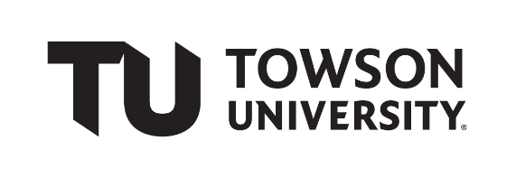

Team Working Agreement

In this course, you will complete several assignments with the same team. To set your team up for success, you will create a working agreement that establishes roles, expectations, communication strategies, etc. By creating this agreement, the goal is to set yourself up for success and to reduce the occurrences of problems. This agreement is expected to be a living document that you can modify throughout the course whenever necessary.

# Team Name

|  |
| --- |
| **NAM NGUYEN** |

*Optional: Add a team logo or mascot.*

# Team Member Information and Roles

|  |  |  |
| --- | --- | --- |
| **Team Member Name** | **Role \*** | **Contact Info (e-mail & phone)**  **Preferred Method of Communication** |
| Jin Chen | Front-End | [jchen42@students.towson.edu](mailto:jchen42@students.towson.edu) / 443 902 1969 |
| Kayla Jurew | Graphics | [kjurew1@students.towson.edu](mailto:kjurew1@students.towson.edu) / 301 848 7863 |
| Eric Tsekouras | Technical | [etseko1@students.towson.edu](mailto:etseko1@students.towson.edu) / 240 298 6398 |
| Craig Benjamin | Back-end | [cbenja6@students.towson.edu](mailto:cbenja6@students.towson.edu) / 240 351 7795 |

* You can leave Role blank for your first revision of the agreement. Roles might include, but are not limited to, Team Manager, Technical Writer, Graphic Designer/Document Formatter, Content Developer, Tester, etc. You can change your role or take on multiple roles for any assignment. It is expected that you all will support each other in the development of assignments. In other words, each assignment has multiple parts, and everyone is expected to contribute part of this content.

# Team Communication and Material-Sharing Strategies

* Group Chat (text)
* Github
* Trello

# Team Values, Behaviors, and Expectations

* Pull your weight
* Answer the group chat in a timely manor
* Talk about deadlines weeks before they are due so we can plan accordingly
* Team agreement to projects/roles and approach
* Meetings at least once a week at future discussed times.

# Methods for Handling Team Issues

* Addressed as a team
* Resolving issues as team
* Problems that occur should have everyone in agreement to the solution
* LISTEN TO EVERYONES VOICE
* Quality check will be performed as a positive reinforcement to help each other out
* Quality of product must be in agreement by team

# Approvals

Each member sign and date below

*We, the undersigned, agree to abide by the above document.*

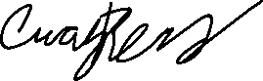

|  |  |  |
| --- | --- | --- |
| **Name** | **Signature** | **Date** |
| Jin Chen |  | 01/31/2023 |
| Kayla Jurew |  | 2/2/2023 |
| Eric Tsekouras |  | 2/2/2023 |
| Craig Benjamin |  | 2/2/2023 |

